**BDA Lab 2 Outputs**

**Name**: Karkala Gaurav Prabhu

**USN**: 1BM17CS136

**Date**: 05/10/2020

1. Create Company database with following collections

1.1. Employee

1.2 Department

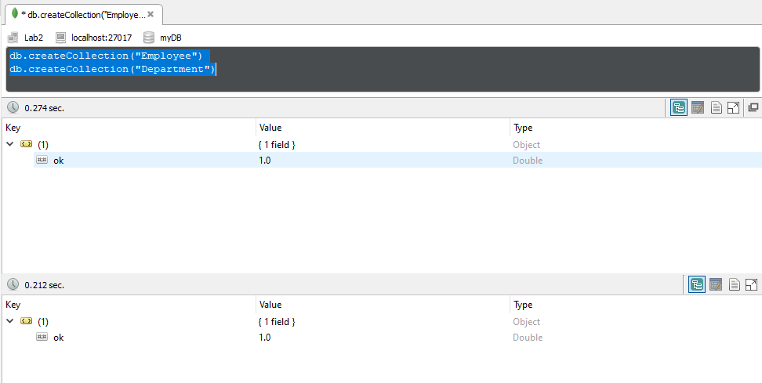

2. Insert at least five documents in each collection using all three methods of insertion.

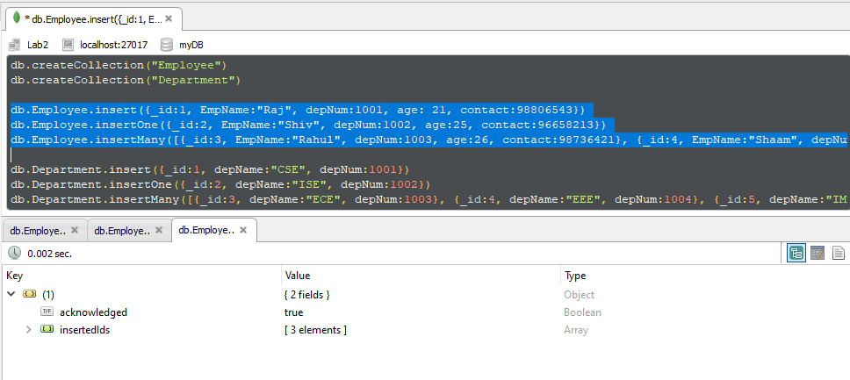

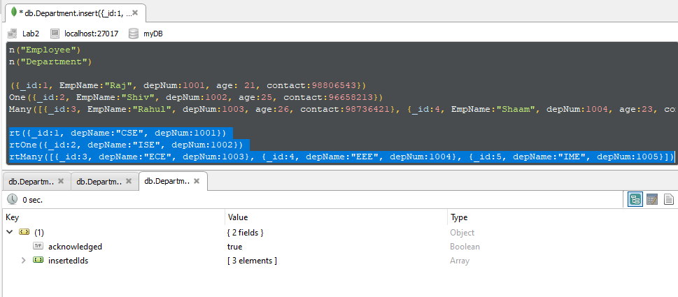

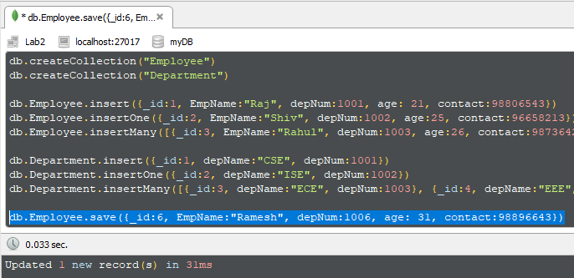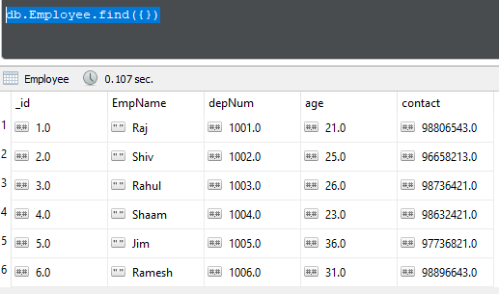

3. Update “Employee” collection to add new field to an existing document.

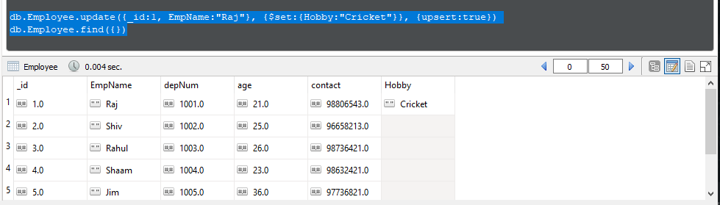

4. Remove a field from an existing document.

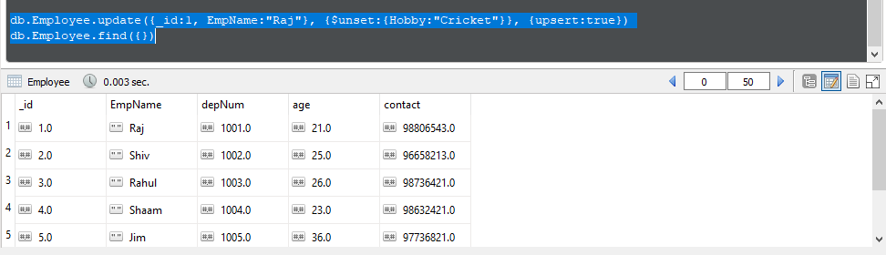

5. Select all documents from both collections.

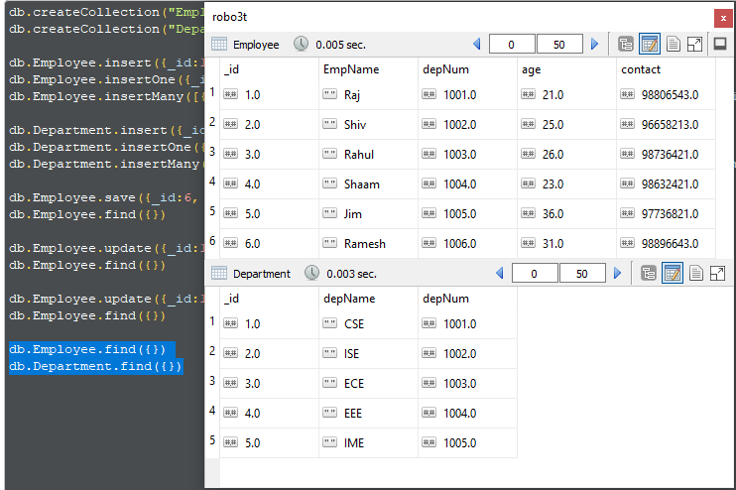

6. Select only employee name and department number whose department number falls between 1001 to 1005.

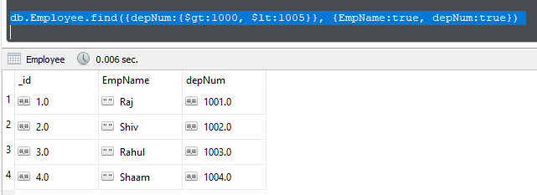

7. Select employee documents whose name begins with “A”.

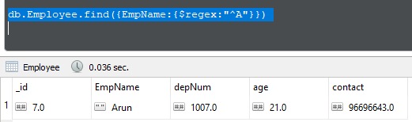

8. Select employee document s whose age is greater than 30.

